Average Age of Exit of the Augusta Military Academy
May Be Shared – Calvin Hulleman
The Augusta Military Academy was formally founded in 1879 and remained open until 1984. Throughout it’s time training cadettes, it kept records of cadettes birth, death, and exit date from the academy. From which, our main goal is to assess the average age of a cadette when they left the academy (for any reason). For our analysis here, all the names have been randomly shuffled to anonymize the data. The main issue however, as with most digitized datasets, is that there is hardly a consistent format for the data. There are two main columns of interest: Exit year (the year that they left) and Places & Date of Birth & Death (from which we will extract the birth year). Of the over 12000 entries, many of them either had missing values for birth or exit date altogether, in which case they were removed, or they did not contain clear years (i.e. 05/06/80 could refer to either 1980 or 1880). For the latter issue, a handful of methods were used to attempt to extract the year, if none were successful the entry would be removed. First, if the exit year was before 79, we could safely assume it referred to the 1900s as you could not leave school before 1879 as it did not exist yet. Similarly, if it was after 84, it was safe to assume it meant 18XX as the school closed in 1984. Finally, if either the birth or exit year did not contain a complete year, but the respective birth or exit year did, we could then extract the full year (birth year must always be before the exit). The result of this method is shown below:
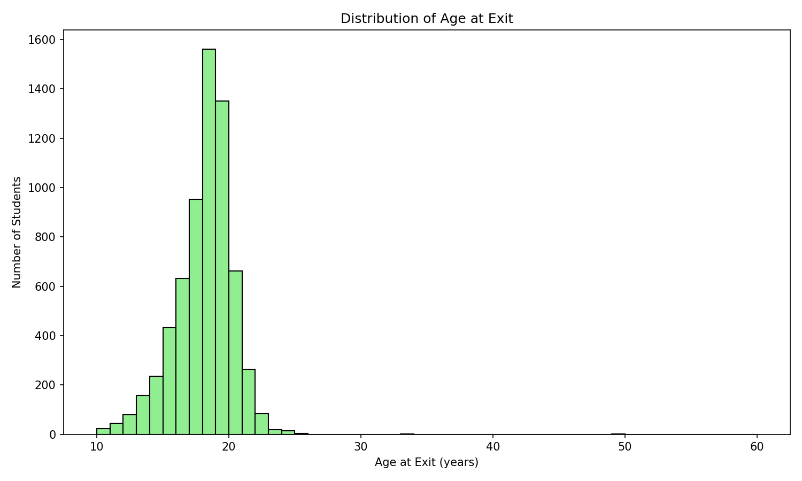
The average age at exit for a cadette is 17.7 years old with a median value of 18 years. There are several outliers in the data at age 33 and 49. It is likely that these outliers are not students but rather faculty as there were some mixed in with often no clean way to distinguish them.
The data shows that, more than likely, the majority of students who attended AMA did not graduate by the time that they left. It is worth noting that this data is far from trustworthy. There is little in the way of knowing what prevent of our data featured faculty and staff and our final data set contained a little over half of the initial cadettes entered due to missing values or indistinguishable dates.

